Redfield FFA Agronomy Team brings home Bronze placing at the National FFA Convention

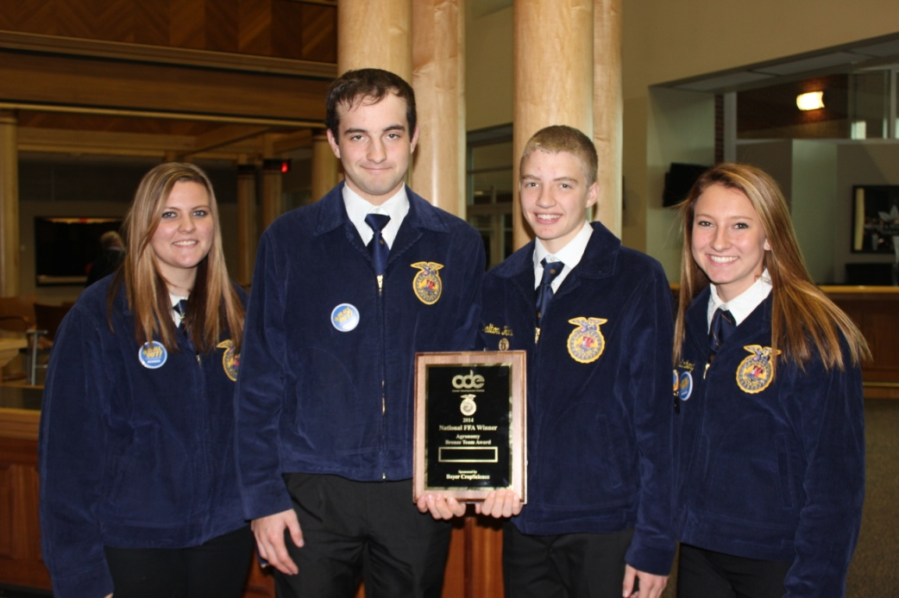

Picture (Left to Right): Chantel Wobbema, Kris Blume, Dalton Howe, Tana Muellenberg

The Redfield FFA Agronomy Team attended the National FFA Convention October 29th through November 1st to judge in the National Agronomy CDE. They competed 2 days, the first day which consisted of team problem of which they had to present a 3 year plan for a crop rotation, fertility & chemical use, along with at budget and balance sheet. The second day consisted of individual judging which included: machinery, crop, insect, weed seeds & plant identification, along with seed analysis, soil questions, and determining disease or deficiencies in the crops presented. They attended the Awards Banquet at the Papa John’s Louisville Cardinal Stadium where the team earned a bronze placing and each member of the team earned a bronze placing. On their trip they got to tour the Kinze Planter Factory in Williamsburg, Iowa, the Louisville Slugger Factory & Museum and Churchill Downs in Louisville, Kentucky along with attending a concert and a rodeo. On the way home, they toured the Gateway Arch in St. Louis, Missouri.

