Redfield FFA Chapter Delegates Attend National Convention

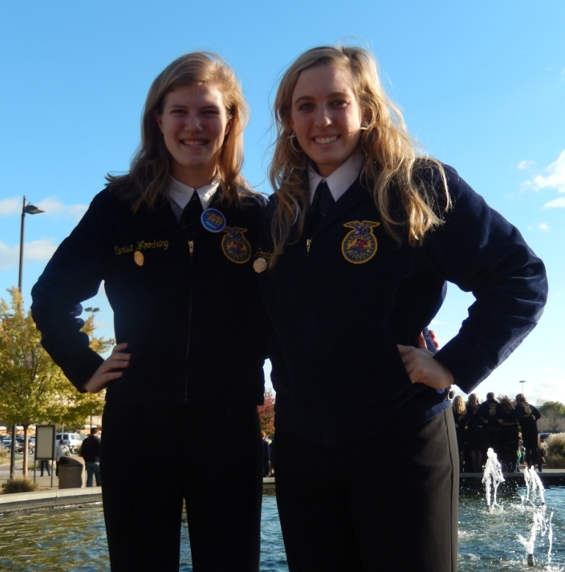

Picture (Left to Right): Marissa Woodring, Jordanne Howe

Marissa Woodring and Jordanne Howe attended the 87th National FFA Convention in Louisville, Kentucky as Delegates from the Redfield FFA Chapter October 29th through November 1st. While at Nationals, they got the opportunity to attend sessions, explore the FFA Shopping Mall and Expo along with touring the Louisville Slugger Factory & Museum and Churchill Downs.

